INDEX

  - INTRODUCTION
  - PROJECT DESCRIPTION
  - HARDWARE AND SOFTWARE REQUIREMENT
  - VISUAL BASIC AS A developing TOOL
  - MICROSOFT ACCESS ANALYSIS TOOLS
  - project coding
  - FORMS AND OUTPUT
  - BIBILOGRAPHY

INTRODUCTION

Introduction:

There are number of web browsers are available for the net surfing. They all have various features and functions. If we visit any particular site regularly then we have to make it favorite, if we want to save a webpage then we can do.
So, we got an idea of designing a web browser in VB6.0.
A web browser is a software application which enables a user to display and interact with text, images, videos, music, and other information that could be on a website. Text and images on a web page can contain hyperlinks to other web pages at the same or different website.
Web browsers allow a user to quickly and easily access information provided on many web pages at many websites by traversing these links. Web browsers format HTML information for display so the appearance of a web page many differ between browsers.
Web browsers communicated with web servers primarily using HTTP (hypertext transfer protocol) to fetch web pages. HTTP allows web browsers to submit information to web servers as well as fetch web pages from them. Pages are identified by means of a URL (uniform resource locater), which is treated as an address, beginning with “http://” for HTTP access.


    - PROJECT DESCRIPTION

Project Description:

Our Project title is “Web Browser” where we are developing a browser in visual Basic.
We have to run our project and in that form we will be able to surf. If we want to make some site favorite then it can be done easily.
We can save the details of the page by saving it. We can save the URL of various sites in our database with the various Categories like Educational, Motivational, News etc. so that we select the category then its related saved favorite sites will be appear and we can go to the particular site.
If we are not online i.e if internet is not working then we can read or view the saved pages. If the internet is working then we can surf it through our project.
Address bar is used to enter website and page names. Address bar works as a dropdown menu showing all previously visited sites. At the end of address bar you will find go button that is not very useful as by simply clicking enter (after typing or selecting domain name) you will be directed to the site.

Integrated search engine tool is relative new features in web browser. It allows selecting your favorite search engine and doing a quick search by typing in a search term.



HARDWARE AND SOFTWARE REQUIREMENTS

HARDWARE AND SOFTWARE REQUIREMENTS
HARDWARE
- 350 Mhz processor
- Max 40 GB HDD
- 1 GB RAM
- Key Board
- Mouse
SOFTWARE
  - WINDOWS 9X AND ABOVE
  - VISAUL BASIC 6.0
  - MS-ACCESS-2010



VISUAL BASIC AS A DEVELOPING TOOLS

VISUAL BASIC AS A DEVELOPING TOOLS

What is Visual Basic?
Microsoft Visual Basic, the faster and easiest way to create application for Microsoft Windows. Visual Basic provides us with a complete set of tools to simplify rapid application development.
So what is Visual Basic? The "Visual" part refers to the method used to create the graphical user interface (GUI). Rather than writing numerous lines of codes to describe the appearance and location of interface elements, we simply add pre-built object into place on screen. If we've ever used a drawing program such as paint, we already have most of the skills necessary to create an effective user interface.
The "Basic" part refers to the BASIC (Beginners All Purpose Symbolic Instruction Code) language, a language used by more programmers than any other language in the history of computing. Visual Basic has evolved from the original BASIC language and now contains several thousand statements, functions and keywords, as many of which relate directly to the Windows GUI. Beginners can create useful application by learning just a few of the keywords, yet the power of the language allows professionals to accomplish using any other Windows programming language.
The Visual Basic programming language is not unique to Visual basic. The Visual basic programming system, Application Edition included in Microsoft Excel Microsoft Access and much other window application use the same language. The Visual basic scripting Edition (VBScript) is a widely used scripting language and a subset of the Visual Basic language. The investment we make in the learning Visual Basic will carry over to other areas.
Whether our goal is to create a small utility for our-self or our work group, a large enterprise-wide system, or even distributed application spanning the globe via the Internet, Visual Basic has the tools we need.
Data access features allows us to create database, front-end application, scalable sever-side components for most popular database formats, including Microsoft SQL, sever and other enterprise-level database.
ActiveX technology allows us to use the functionally provided by other application, such as Microsoft Word Processor, Microsoft Excel Spreadsheet and other Window application. We can even automate application and objects create using the Professional or Enterprise editions of Visual Basic.
Inter capabilities make it easy to provide access to documents and applications across the Internet or Intranet from within our application, or to create Internet sever applications.

Our finished application is a true .exe file that uses a Visual Basic Virtual Machine that can freely distribute.

Visual Basic is Small. Simple and Smart
The following sections describe the different types of files and objects that we can include in a Visual Basic project.
FORM Modules
Form Modules (.frm file name extension) can contain textual description of the forms and its control, including their property setting.

Class Modules
Class Modules (.els file name extension) are similar to form module, expect that they have no visible user interface. We can use class module to create our own objects, including code for methods and properties.
VB DATABASE CONNECTIVITY
What is ODBC (Open Database connectivity)?
A standard protocol that permits applications to connect to a variety of external database severs or files. ODBC drivers used by the ODBC drivers managers permits access to SQL sever and several other data sources, including text files and Microsoft Excel spreadsheets.
A standard protocol that permits applications to connect to the Variety of external database servers or files. ODBC drivers used by the Microsoft Jet Database engine permit access to Microsoft SQL server other external databases.
The ODBC Application programming interface (API) may also be used ODBC drivers and the database they connect to without using the Microsoft Jet Database engine.
Open Database Connectivity. A specification for an Application Programming Interface (API) that define a standard set of routine with which an application can access data in a data source. Application can use ODBC by referring API functions directly, or by using Data Access objects (DAO) or Remote Data Objects (RDO).
ODBC Data Source
A term used to refer to a database or a database server used as a source of data. ODBC data sources are referred to by their Data Source Name (DSN).Data Source can be created by using Windows Control Panel or the Register Database method.

Microsoft Jet Connect OBDC Data Source
An ODBC Data Source that is accessed by using Data Access Objects (DAO) and the Microsoft Jet Database engine.

ODBC Driver
A dynamic link library (DLL) used to connect a specific open database connectivity data source with another (client) application.
ODBC Driver Manager
An application that manages connections between ODBC-enabled data sources and the drivers used to access them.
Data Object Model
An object model defines a hierarchy of objects that gives structure to an object-based program. By defining the relationship between objects that are part of the program, an object model organized the object in a way that makes programming easier.
The public object model of a component is especially important because the entire programmer who employs the component as part of their application uses it.

DAO
DAO (Data Access Objects) was the objects-oriented interface that exposed the Microsoft Jet Database engine (used by Microsoft Access) and allows Visual Basic developers to directly connect to Access tables as well as other database-through ODBC. DAO is suited best for either for single-system application or for small, local development.
RDO
RDO (Remote Data Objects) is an object-oriented data access interface that exposes virtually all of ODBC's low-level power and flexibility. RDO is limited, though in that it doesn't access Jet or ISAM database very well, and that it can access relational database only through existing ODBC drivers. How, RDO has proven to be the interface of choice for a large number of SQL severs Oracle, and other large relation; database developers. RDO provides the object, properties, and methods needed to access the more complex aspects of stored procedures and complex result sets.
ADO
ADO is the successor to DAO/RDO. Functionally ADO 2.0 is most similar to RDO, and there's generally a similar mapping between the two models. ADO "flattens" the object model used by DAO and RDO, meaning that contain fewer objects and properties, methods (and arguments), and events. For example, ADO has no equivalents to the RDO engine and RDO environment objects, which exposed the ODBC driver manager and interfaces. Nor can we currently create ODBC data sources from ADO, despite the fact that our interface might be thought the ODBC OL DB service provider.



    - MICROSOFT ACCESS ANALYSIS TOOLS

FEATURES OF VISUAL BASIC:-
VISUAL BASIC an excellent platform for rapid application developed. Using Visual Basic, you can quickly create solution for most business needs, from simple to complex.

1. It provide quick editing, testing, debugging.
2. It is based on BASIC programming language.
3. It is highly productive development tool.
4. It is a first programming, which makes use of GUI
5. It is Event Driven programming.
6. IT is object-oriented programming.
7. It is widely used as Front -end tool.
8. A common programming language for most of the Microsoft Office application based on VISUAL BASIC.
9. In VB both Compiler & Interpreter are used.
10. It provides OLE (Object Linking & Embedding) programming supports.
11. It supports multiple platforms.

MICROSOFT ACCESS ANALYSIS TOOLS
Microsoft Access includes two tools that can help us to refine our database design. The Table Analyzer Wizard can analyze the design of one table at a time, can purpose new , and can restructure a table into new table makes sense.

The performance Analyzer can either database or make recommendation and suggestions for improving it. The wizard can also implement these recommendation and suggestions.
About Designing Database
Before we use Microsoft Access to actually build the table, and other object that will makeup our database, it is important to take time to design our database. A good database design is the keystone to creating a database that does what we want it to do effectively, accurately and efficiently.

Step in designing a Database
Following basic steps are use in designing a database:
1. Determine the purpose of our database.
2. Determine the table we need in the database.
3. Determine the field we need in the table.
4. Identify field with unique values.
5. Determine the relationship between tables.
6. Refine our design.
7. Add data and create other database objects.
The heart of database is the information it holds. But there is other important elements usually referred to as objects, in an access database there are various kinds of objects we'll be working with in access.

DATABASE & RDBMS CONCEPTS DBMS :-
A database is a collection of related data. Data normally has some inherent meaning database can be collection of population, statistics, compilation of sales figure University keeping track of student performance etc.
A database management system (DBMS) is general-purpose software that offers the facilities to define construct and manipulates a database to provide information from the analysis of the data. Defining the database means to describe the various types of data that constitute. Constructing a database is a process of physically storing the data into the medium. Manipulating the database it is a process of extracting useful information or updating it to reflect changes. Report generation also forms an important activity of a DBMS, which it is designed to clear it. Any standard database has the properties listed below.

DATA Integrity
Data integrity is more important in a database system than in a private file environment in a database system the in a private file environment, because the database is shared. So if redundancy is removed, however the database may still contain in correct data. Centralize control of database helps in avoiding this situation. DBA is permitted to define validation procedure to be carried our whenever any update operation is attempted.

Data Independence
Data independence is the immunity of application to change in storage structure and access strategy, which implies that the application concerned don't depend on any one particular storage structure and access strategy. RDBMS
Relational database is defined as collection of related tables. Foundation of related database is relational algebra. The constraints here considered are mathematical relation. Data is always represented in a tabular form, which is referred to, as relation or tables.
The concept of 2D formats for representation of rows and columns in a tabular form is called as relations or tables.

Properties of Relations or Tables
1. There are no duplicate rows.
2. There are no duplicate columns names.
3. Rows order is insignificant.
4. Column order is insignificant.

DIFFERENCE BETWEEN FORMS AND REPORTS
Reports are similar to forms and in fact the report design window shares many of the features to the forms design window. There is some important difference between these two of objects.

One difference is that forms are primarily used to edit of view data on your computers screen. When we move through a form, we usually navigate from one record to another, perhaps displaying related forms on the as we do so. Reports can be previewed on the screen as well but their main purpose is to present information nicely on the printed page.
Another differences between forms and reports is that reports have a special features to help us summarize data i.e. reports can group sales records by sales person and months and give us summary of the sales for each person by months.
It's not possible to view this kind of summary information using a form unless we go through some hopes with queries first.
ACCESS FIELDS TYPES:
Access has many fields' types. They are listed here with some notes on how each can be used:
AutoNumber: Access automatically assigns number fields when a Record is added to table.
Currency: This type of fields is for money values.
Date/time: Date, time, or date/time combinations go in date/time fields.
Hyperlink: This field holds hyperlink addresses that jump to web sites, database objects, or other files.
Lookup wizard: Lookup fields start a wizard that places lookup
Constraints on table or a query.
Memo: This type of fields holds an unlimited amount of text.
Number: Number formatted in various ways can go in a number field.
OLE object: Object like pictures & word documenting go in OLE.
Text : This type of fields holds text, letters, numbers & other characters.
Yes/No : Value of true or false is stored in this kind of Field, the value can be shown as yes / No, true / false.

KEY-FIELDS:
A key consists of one or more fields whose values uniquely identify each record in a table. Key fields provide some special function in a database.

- They are often used to link tables. They also determine the nature of a relationship.
- Access automatically builds a primary index using any key field in the table. The index makes it easier for access to fine key value and speeds up any searches or other operations that look for values in key fields.



PROJECT CODING

Splash form:
Private Sub Timer1_Timer()
Unload Me
frmlogin.Show
End Sub

Login Form:

Private Sub cmdlogin_Click()
If txtuser.Text = "a" And txtpwd.Text = "b" Then
Unload Me
frmmain.Show

Else
MsgBox " Enter Correct User name and Password", vbCritical + vbOKCancel

End If

End Sub

MDI From:

Private Sub mnuadd_Click()
frmadd.Show
End Sub

Private Sub mnubrowser_Click()
frmbrowser.Show
End Sub

Private Sub mnuoffline_Click()
frmoffline.Show
End Sub

Private Sub mnuonline_Click()
frmonline.Show
End Sub

Online Form:

Private Sub cmbcategory_Click()
cmbwebsite.Clear
str = "SELECT WEB_SITE FROM sites where CATEGORY='" & cmbcategory.Text & "'"
rs.Open str, cn, 1, 3
While Not rs.EOF
cmbwebsite.AddItem (rs.Fields("WEB_SITE"))
rs.MoveNext
Wend
rs.Close
End Sub

Private Sub cmbwebsite_Click()
WebBrowser1.Navigate "http://" & Trim(cmbwebsite.Text)

End Sub

Private Sub cmdall_Click()
cmbwebsite.Clear
str = "SELECT distinct WEB_SITE FROM sites"
rs.Open str, cn, 1, 3
While Not rs.EOF
cmbwebsite.AddItem (rs.Fields("WEB_SITE"))
rs.MoveNext
Wend
rs.Close
End Sub

Private Sub cmdcancel_Click()
Unload Me
End Sub

Private Sub Form_Load()
str = "SELECT distinct CATEGORY FROM sites"
rs.Open str, cn, 1, 3
While Not rs.EOF
cmbcategory.AddItem (rs.Fields("CATEGORY"))

rs.MoveNext
Wend
rs.Close
str = "SELECT distinct WEB_SITE FROM sites"
rs.Open str, cn, 1, 3
While Not rs.EOF
cmbwebsite.AddItem (rs.Fields("WEB_SITE"))
rs.MoveNext
Wend
rs.Close
End Sub

Private Sub WebBrowser1_StatusTextChange(ByVal Text As String)

End Sub

Ofline Form:

Private Sub cmdall_Click()

On Error Resume Next
With CommonDialog1
.DialogTitle = "Open File"
.Filter = "Web page (*.htm;*.html) | *.htm;*.html|" & _
"All Supported Picture formats|*.gif;*.tif;*.pcd;*.jpg;*.wmf;" & _
"*.tga;*.jpeg;*.ras;*.png;*.eps;*.bmp;*.pcx|" & _
"Text formats (*.txt;*.doc)|*.txt;*.doc|" & _
"All files (*.*)|*.*|"
.ShowOpen
.Flags = 5
WebBrowser1.Navigate2 .FileName
End With
End Sub

Private Sub cmdcancel_Click()
Unload Me
End Sub

Private Sub Form_Load()

End Sub

Private Sub Timer1_Timer()
WebBrowser1.Silent = True
Timer1.Enabled = False
End Sub

Browser Form:

Private Sub cmdsave_Click()
WebBrowser1.ExecWB OLECMDID_SAVEAS, OLECMDEXECOPT_DODEFAULT

End Sub

Private Sub Form_Load()

End Sub

Private Sub Text1_KeyPress(KeyAscii As Integer)
If KeyAscii = 13 Then
WebBrowser1.Navigate "http://" & Trim(Text1.Text)
End If

End Sub

Add Form:

Private Sub cmbwebsite_Click()
str = "select * from sites where Web_site='" & cmbwebsite.Text & "'"
rs.Open str, cn, 1, 3
txtwebsite.Text = rs.Fields("WEB_SITE")
txtcategory.Text = rs.Fields("CATEGORY")
rs.Close
End Sub

Private Sub cmdcancel_Click()
Unload Me
End Sub

Private Sub cmddelete_Click()
If cmddelete.Caption = "Delete" Then
cmddelete.Caption = "Remove"
cmdedit.Enabled = False
cmdnew.Enabled = False
txtwebsite.Visible = False
cmbwebsite.Visible = True
Call filldata
Else

str = "Delete from sites where Web_site='" & txtwebsite.Text & "'"
cn.Execute (str)
MsgBox " Website Detail is Deleted"
Unload Me
End If
End Sub

Private Sub cmdedit_Click()
If cmdedit.Caption = "Edit" Then
cmdedit.Caption = "Update"
cmddelete.Enabled = False
cmdnew.Enabled = False
txtwebsite.Visible = False
cmbwebsite.Visible = True
Call filldata
Else

str = "select * from sites where Web_site='" & txtwebsite.Text & "'"
rs.Open str, cn, 1, 3

rs.Fields("WEB_SITE") = txtwebsite.Text
rs.Fields("CATEGORY") = txtcategory.Text
rs.Update
rs.Close
MsgBox " Website Detail is Updated"
Unload Me
End If

End Sub
Private Sub filldata()
str = "select * from Sites"
rs.Open str, cn, 1, 3
While Not rs.EOF
cmbwebsite.AddItem (rs.Fields("Web_site"))
rs.MoveNext
Wend
rs.Close
End Sub
Private Sub cmdnew_Click()
If cmdnew.Caption = "New" Then
cmdnew.Caption = "Save"
cmdedit.Enabled = False
cmddelete.Enabled = False
Else

str = "select * from sites"
rs.Open str, cn, 1, 3
rs.AddNew
rs.Fields("WEB_SITE") = txtwebsite.Text
rs.Fields("CATEGORY") = txtcategory.Text
rs.Update
rs.Close
MsgBox " New Website Address is Added"
Unload Me

End If
End Sub



    - PROJECT OUTPUT FORM

Splash Form:

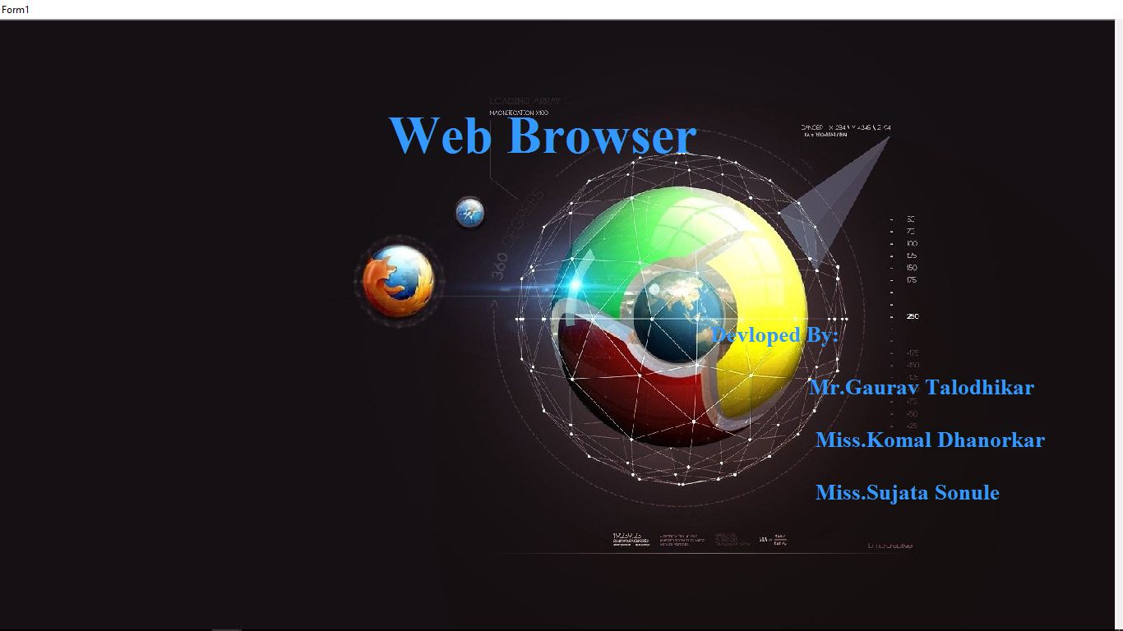

Login Form:

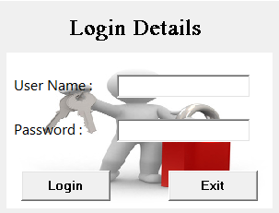

MDI Form:



Online Form:

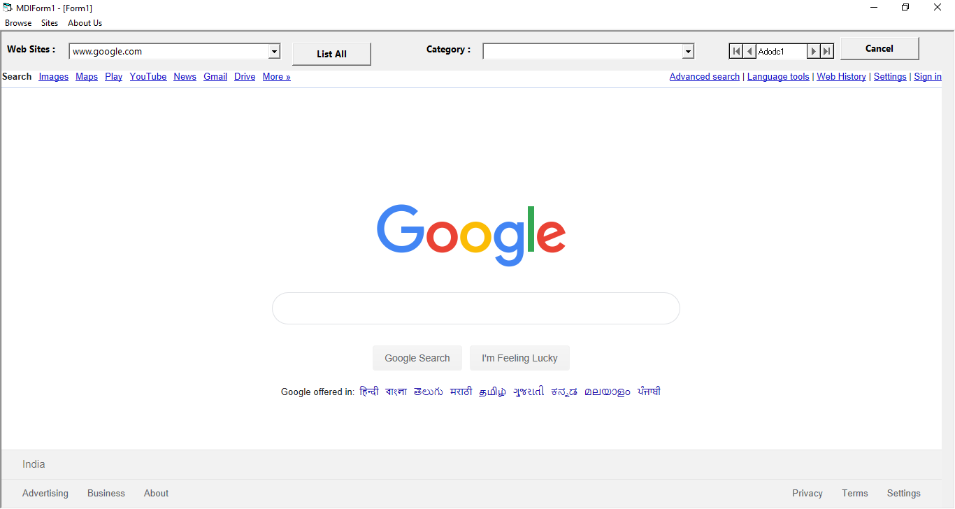

Ofline Form:

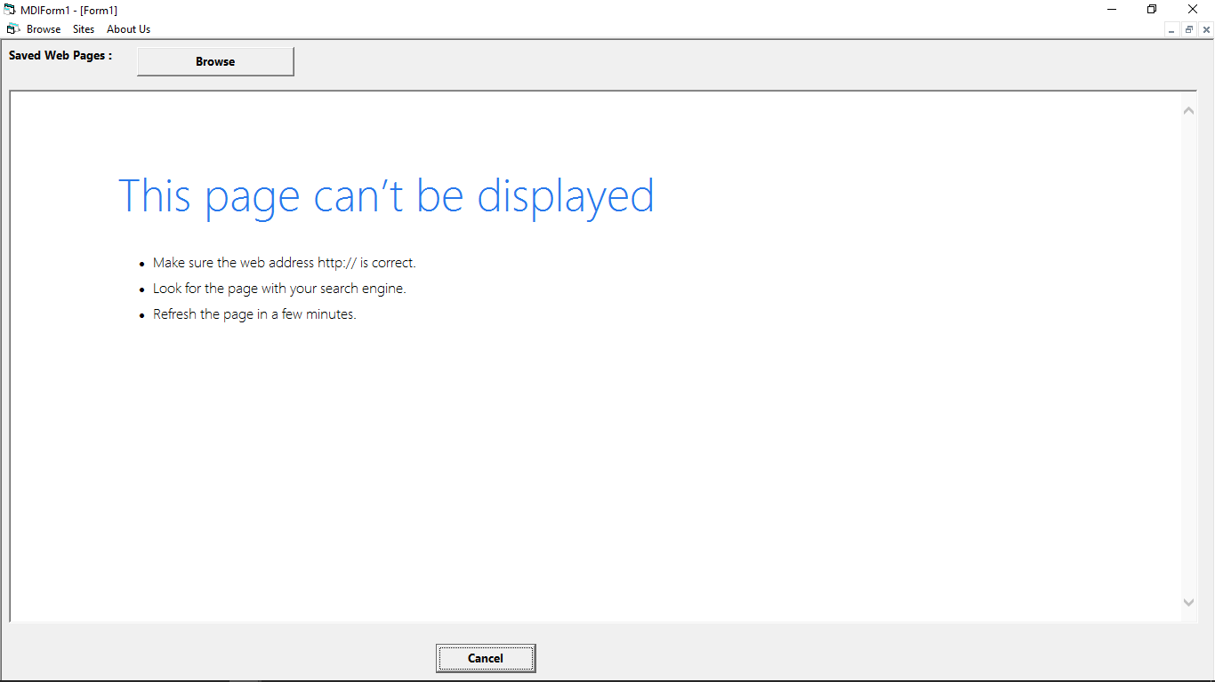

Browser Form:

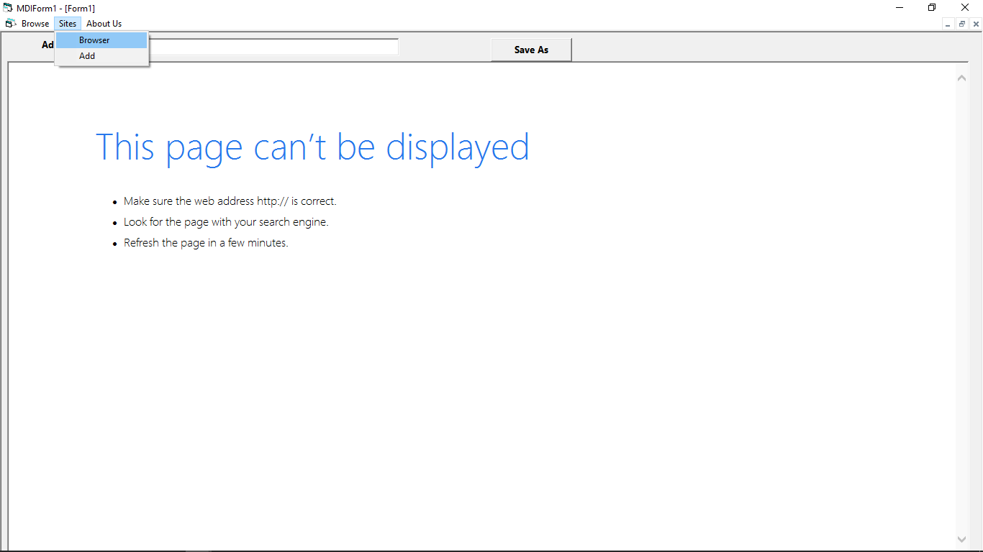

Add Form :

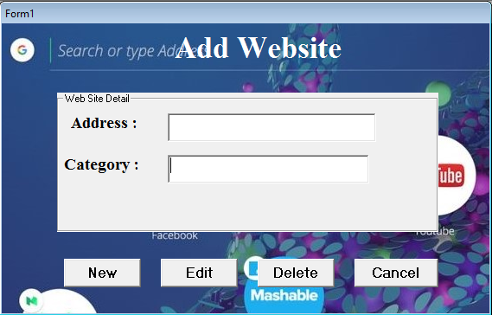



SCOPE AND LIMITATION

- One can surf for any kind of information over the web browser. Information regarding various topics such as Technology, Health & Science, Social Studies, Geographical Information, Information Technology, Products etc can be surfed with help of a search engine.

- Apart from communication and source of information, web browser also
serves a medium for entertainment. Following are the various modes for
entertainment over web browser.

  - Online Television
  - Online Games
  - Songs
  - Videos
  - Social Networking Apps
- Web Browser allows us to use many services like:
  - Internet Banking
  - Matrimonial Services
  - Online Shopping
  - Online Ticket Booking
  - Online Bill Payment
  - Data Sharing
  - E-mail

- No need to go with already existing browsers.
- No need to make favorite in the existing browser.
- We can make favorite site in our browser.
- We can check internet is working or not.
- We can view saved web pages.

Limitations :
- When the Web browser is refreshed, you need to log in the Web application again.
- By default , you can run no more than two appeon web applications in different tab pages or different browser.
- Internet connections must available for using browser.



    - Bibliography

bibliography

- S.B. Kishor, “DBMS and Oracle”, Das Ganu, ISBN : 978-93-81660-08-9
- Sanjay Saxena, “MS Office 2007 in a Nutshell”, Vikas Publication, 2011,
ISBN-978-81-259-5036-3
- Rutkosky, Seguin, Audrey, “Microsoft office 2007”, BPB,
ISBN-10:81-8333-228-5/13:978-81-8333-228-6
- Steve Brown,”Visual Basic 6.0 Complete”, Complete Idiot’s Books,
ISBN 978-0789718129
- Dr. S.B. Kishor,”Front End Development using Visual Basic”, Das Gan Prakashan,
ISBN 978-93-81660-0-5
- Evangelos Petroutsos ,”Mastering Visual Basic 6 “, BPB, 2005
ISBN-81-7635-269-1.
- Moel Jerke,”Complete Reference Visual Basic 6”,TMH, 2004,
ISBN -0-07-463666-9.

